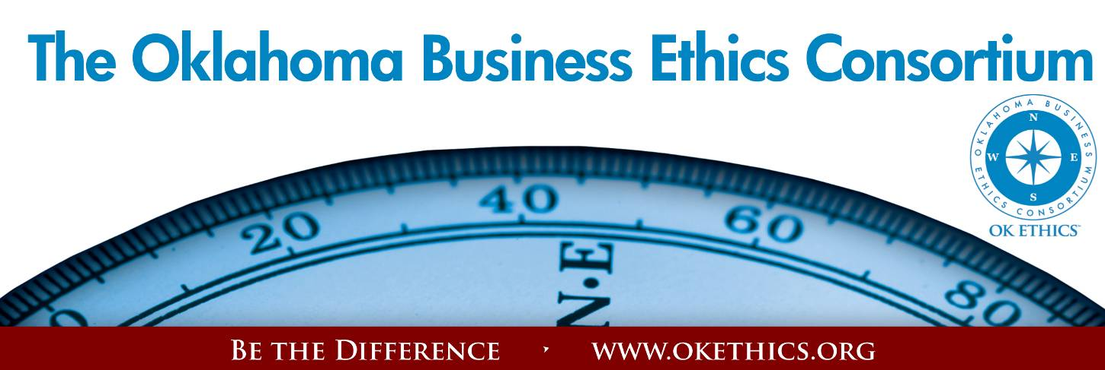
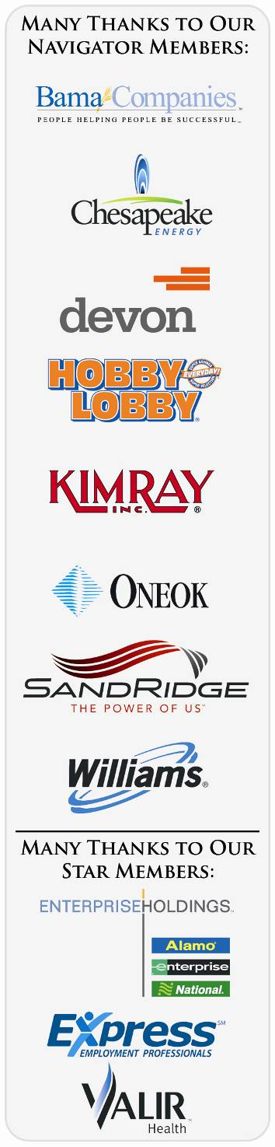
Agenda – February 8, 2012
- Welcoming Remarks & Kudos – Garyl Geist, Chief Operating
Officer, Oklahoma Allergy & Asthma Clinic;
President of OK Ethics Board
- “Gratitude” - Randy Thurman; Co-President,
Retirement Investment Advisors; OK Ethics Board Member
- Upcoming Events - Shannon Warren, Founder, OK Ethics
- Keynote - “A Champion’s Perspective” Jay Wilkinson
- Adjourn

Welcome:
- Jalisha Petties, Member Care Coordinator,
Accounting Principals
- Sue Miller, Accel Financial Staffing

CALL FOR NOMINATIONS: ANNUAL COMPASS AWARDS
Deadline for Applications: March 22
International speaker Stephen M. R. Covey is the New York Times and #1 Wall Street Journal bestselling author of The Speed of Trust: The One Thing That Changes Everything. He is the former CEO of Covey Leadership Center, which, under his stewardship, became the largest leadership development company in the world and today, as FranklinCovey, teaches trust in more than 100 countries.
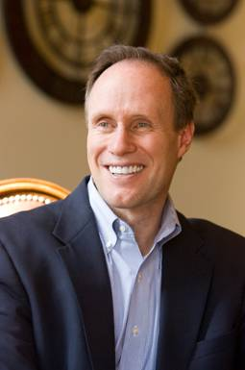 | APRIL 18  COMPASS AWARDS  Featuring  STEPHEN M. R. COVEY  10% Early Bird Discount | 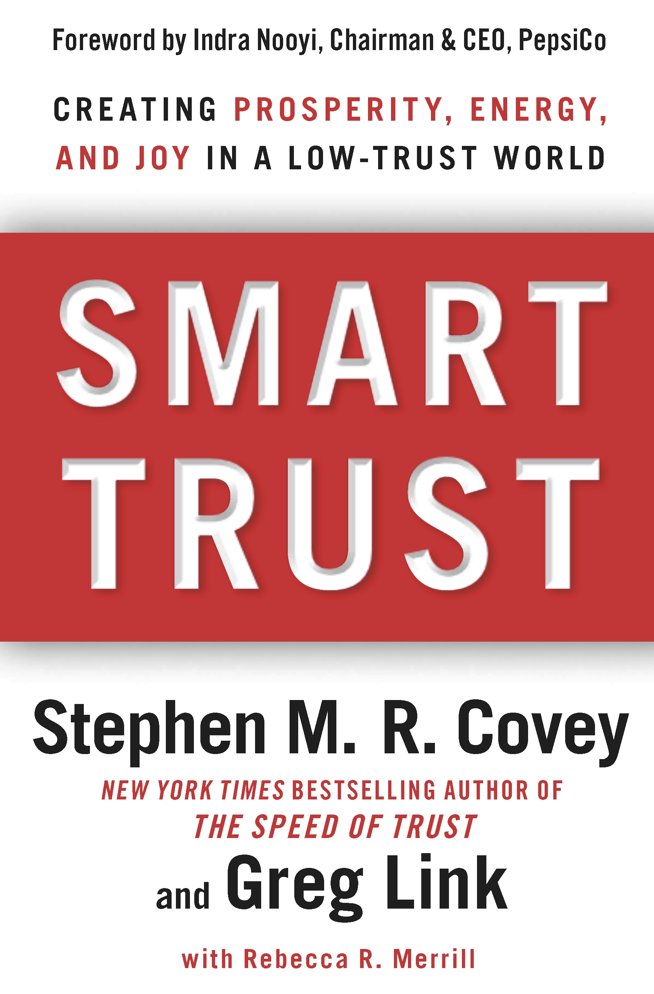
REMINDER: PLEASE PICK UP CPE’S
AT CONCLUSION OF EVENT.

Oklahoma Business Ethics Consortium Guiding Principles
Adopted July, 2004
To ensure that the Consortium fosters positive characteristics of integrity in the successful achievement of its goals, these Guiding Principles were discussed and adopted (with revisions) during a milestone planning session held by Consortium leaders in Stroud on June 18, 2004. These principles were developed based on the Character First Institute's values and philosophies.
I. Responsibility to Self and Others:
- Service:
  - Passion for promoting ethics and integrity
  - Encouraging the promotion of ethical behavior through personal actions and
  - Sharing ideas and resources
  - Responsibility and accountability for fulfilling the mission of the Consortium.
- Collaboration:
  - Achievement of common goals through the promotion of ethical, mutually beneficial relationships
  - Service to the Consortium over promotion of self-interest
  - Cooperation emphasized over competition in promoting ethical business conduct
  - Members collaborate by being constructively engaged in discussions regarding ethics
  - Seeking consensus in interactive discussions regarding ethical matters.
- Respect:
  - Members may become aware of confidential information shared by others in an effort to determine an ethical course of action. We ask members to be sensitive in recognizing and respecting the efforts made toward achieving ethical behavior. In that vein, public disclosure of this information is discouraged.
  - We respect other members and the process by:
    - Exhibiting listening skills and actively listening to discussions
    - Being open to other points of view and outcomes
  - We are an inclusive organization and demonstrate this by welcoming members who are in different stages of learning as applied to ethical behavior.
II. Lead with Integrity
- Dependability:
  - Members are asked to demonstrate their support of this initiative by consistently attending meetings.
- Initiative:
  - Recruiting other members who have demonstrated a desire to promote ethical behavior in their organizations.
  - Recognizing what needs to be done to help promote the Mission of the Consortium and taking action to assist in that effort.
- Honor:
  - Members are asked to honor the Consortium through the practice of integrity and ethical behavior in their business dealings.
  - We express gratefulness to our hosts, sponsors and speakers; as well as to those whose volunteer service makes OK Ethics a stronger organization.
  - Realizing that each of us is in a mode of continual learning, we demonstrate humility, care and compassion when sharing our thoughts and knowledge.
- Courage:
  - Speak the truth with confidence and encourage others to do the same.
III. Inspire Trust
- We serve and promote the cause of truth with integrity, objectivity and fairness to all persons.
  - We hold ourselves accountable by consistently honoring our word.
  - We extend trust abundantly to those who have earned it.
  - Trust, once earned, will not be taken for granted, manipulated or abused.

UPCOMING OK ETHICS EVENTS:

OKLAHOMA CITY CHAPTER

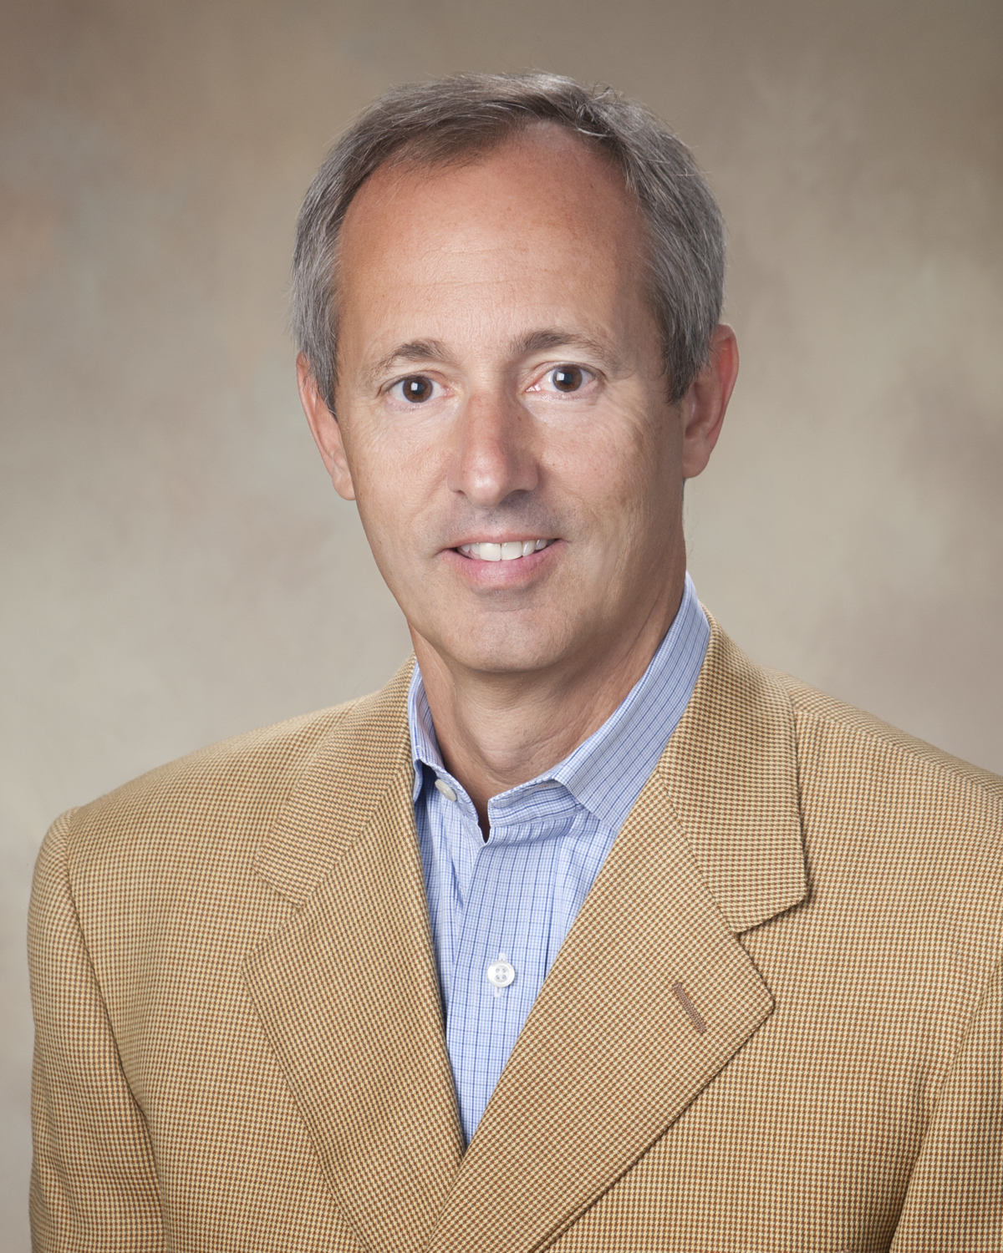 | March 14, 2012  “The Slippery Slope”  David Myers  Former Worldcom Controller  Recommended for 1 CPE in Ethics

APRIL 18
COMPASS AWARDS

Featuring

STEPHEN M. R. COVEY

UPCOMING OK ETHICS EVENTS: TULSA CHAPTER

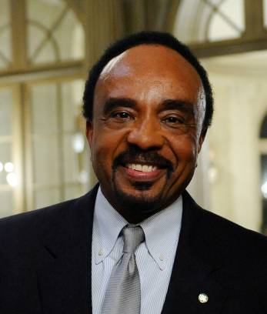 | 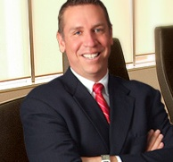
Clifton Taulbert  Building Community Institute  February 23, 2012 | Professor Andrew Urich, JD  Oklahoma State University  March 24, 2012


VOLUNTEER RECOGNITION:
OK Ethics relies primarily on volunteers to achieve the organization’s successful pursuit of Oklahoma’s values of integrity at work. However, the expanding operations required a more consistent approach. Last month, with the assistance of Brent Martens of Accounting Principals, we recruited Jalisha Petties who will be available to help members with billing questions and registration on a regular basis from 8:30 to noon, Monday thru Friday. We are also thankful to Reneé Kissler of Accel Financial Staffing whose employee, Sue Miller, will be preparing name tags for us on a regular basis.
Registration Team: These dependable individuals show up every month to diligently record
our guests’ attendance and handle the collection of fees:
- Mark Neumeister, Chairperson; D. R. Payne & Associates:
Join our team - Contact our leadership
Membership & Recruiting: Shannon Warren, Founder, OK Ethics
warrenokla@cox.net or 858-2233
Ambassadors: Linda Streun, Director of Human Resources,
Ideal Homes, lindastreun@ideal-homes.com
Registration: Mark Neumeister, D. R. Payne; 272-0511; moneumeister@drpayne.com
  - Mary Vaughn, CPA
- Joe Walker, Chairperson (Prepaid members); Wilbanks Security
  - Marvinette Ponder, Devon Energy
Ambassador Team: These friendly people welcome our guests each month and assist in helping them locate seats. They also arrive early to help distribute agendas.
Team Leaders:
- Linda Streun, Ideal Homes of Norman: Chairperson

Team Members:
- Kristy Boone, Ideal Homes
- Scott Harris, Oklahoma Baptist University
- Wayne Hart, Legal Shield
- Jenny Hatton, Boeing
- Brent Martens, Accounting Principals
- Tammy McKeever, Enterprise Holdings
- Larry Musslewhite, Retired
- Connie Root, Walker Companies
- Dr. Earlene Smith
- Lynn Willis, Metro Technology Centers

Table Hosts:
Nancy Hyde, Hyde & Company
Tom Shehan, Nextep
Agendas: Metro Technology Centers, Quality Services and Media Departments
Accounts Receivable Reconciliation: Susan Pate, Stinnett & Associates
Book sales: Lindsay Burzinski, St. Luke’s United Methodist Church, Threefold Bookstore
CPE’s: Michael Mount, CPA, Oklahoma Accountancy Board
Facilities & Logistics: Jamie Potter, Eide Bailly
Pre-meeting slide show: Connie Rutz, Maximum Multimedia Creations
OK ETHICS VISION: To be recognized as a statewide and national forum for promoting business ethics.

General Program Disclaimer:
Members of the Oklahoma Business Ethics Consortium frequently share information concerning various issues and developments that may have legal implications. The discussions, commentary, and handouts at Consortium meetings or presentations to other organizations are for general informational purposes only. They cover only some aspects of the subject topic, and do not constitute a complete legal analysis of the topic or how it might apply to any particular set of facts. Before taking any action based on information presented during a Consortium event, participants are encouraged to consult a qualified attorney. The observations and comments of presenters at Consortium meetings and networking are the views and opinions of the presenter and do not constitute the opinion or policies of the Consortium or any of its members. Presenters are respectfully requested to avoid profanity, preaching, politics, put-downs and self-promotion during their lectures

CPE CERTIFICATES
It is the responsibility of participants to demonstrate applicability of each program as it relates to his/her area of practice. OK Ethics makes no guarantees. Also, attendees must be present to accept CPE certificates and these will be issued at the back of the room upon the conclusion of the program. Please note that we do not have the manpower capabilities to email these later. CPE certificate recipients must be registered on our attendance list to receive a certificate, so please be sure to check in with the registration team.

DO YOU KNOW OTHERS WHO SHARE VALUES OF INTEGRITY AT WORK?

Please help us recruit other companies to join the momentum. OK Ethics has nearly 700 members representing over 200 companies. We grow almost entirely by word-of-mouth and need your help in order to continue in our endeavor to promote Oklahoma values of integrity at work. In fact, please consider helping us with some targeted recruiting initiatives. If you know of individuals at these companies (Dell, Love’s, Continental Resources, OKC Thunder)
or others who share your interest in high ethical standards,
please invite them to attend our next event.

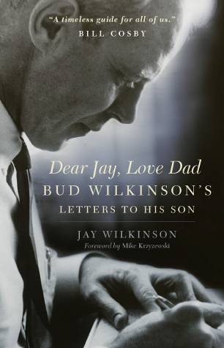 | February 8, 2012  “A Champion’s Perspective”  Jay Wilkinson,  Son of OU Coach Bud Wilkinson  Recommended for 1 CPE in Ethics  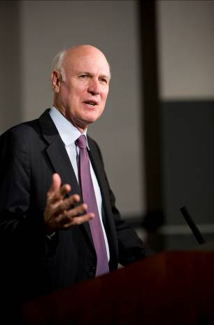  This program covers a broad scope of character traits and values central to promoting a culture of integrity. It is intended for a broad base of business leaders and professionals.  No prerequisites.

Jay will be available for a book-signing immediately following this presentation. Please make checks payable in the amount of $27.04 to “Threefold Books.” (Credit cards accepted.)

“A Champion’s Perspective”
      - Introduction

      - Definitions of a champion:

- Webster’s
      - Warrior, fighter
      - A militant advocate or defender <a champion of civil rights>
      - One that does battle for another's rights or honor <God will raise me up a champion — Sir Walter Scott>
      - A winner of first prize or first place in competition; also : one who shows marked superiority <a champion at selling>
- Bud Wilkinson’s
“Showing thoughtfulness and kindness to others and having an unselfish attitude of service to others.”

- Four Core Principles
  - Values
  - Attitude
  - Preparation
  - Perseverance

- Seven Other Themes
  - The Will to Win
    - All champions have this quality
    - My father always asked his players, “How good do you want to be?”
  - Integrity
    - Begins with being true to ourselves before we can turn outward to others with proper moral conduct.
    - There has never been a time in history when mankind was so in need of moral, religious and political leadership, etc.
    - Must always tell the truth; must be responsible, dependable and reliable.

The Man in the Glass
By Peter Dale Wimbrow Sr.

When you get what you want in your struggle for self
And the world makes you king for a day
Just go to the mirror and look at yourself
And see what that man has to say.
For it isn’t your father, or mother, or wife
Whose judgment upon you must pass
The fellow whose verdict counts most in your life
Is the one staring back from the glass.
He’s the fellow to please – never mind all the rest
For he’s with you, clear to the end
And you’ve passed your most difficult, dangerous test
If the man in the glass is your friend.
You may fool the whole world down the pathway of years
And get pats on the back as you pass
But your final reward will be heartache and tears
If you’ve cheated the man in the glass.
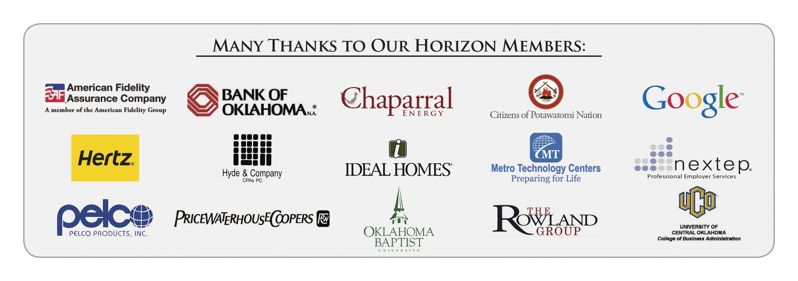

  - Selflessness
    - When we played well, it was because the cause transcended individual recognition or honor.

  - Goal Setting
    - Must define your goals, planning how to achieve them and preparing properly.
    - The will to prepare is more important than the will to win.
    - Must know your competition as well as your company.
    - A story from Jay’s race for U. S. Congress

  - Motivation
    - You must have discipline and respect
    - Two motivation theme stories

  - Determination
    - There are always setbacks and hardships

"The credit belongs to the man who is actually in the arena; whose face is marred by sweat and blood; who strives valiantly; who errs and comes short again and again because there is no effort without error and shortcoming; who knows the great enthusiasms, the great devotion, spends himself in a worthy cause; who at best knows in the end the triumph of high achievement; and who at worst, if he fails, at least fails while daring greatly, so that his place shall never be with those cold and timid souls who have never tasted victory or defeat."
Theodore Roosevelt
American 26th US president (1901-09), 1858-1919

  - Faith
    - Faith was an important ingredient in our country’s growth and development.
    - Faith provides energy and strength to others.
    - Faith strengthens the bond between those we love.

- Conclusion

To leave the world a bit better ...
to know that one life has breathed easier because you have lived.
This is to have succeeded.
- Ralph Waldo Emerson
Programs Focused on Integrity - (Not affiliated with OK Ethics)

For nearly nine years, we have been inspired by our friendship with Character First. Leaders with this organization provided the wisdom and insight for OK Ethic's Guiding Principles. Go to www.characterfirst.com to learn more about tools to help you integrate character and ethics into your organizational culture, or contact John Burnett or Steven Menzel at 405-815-0001

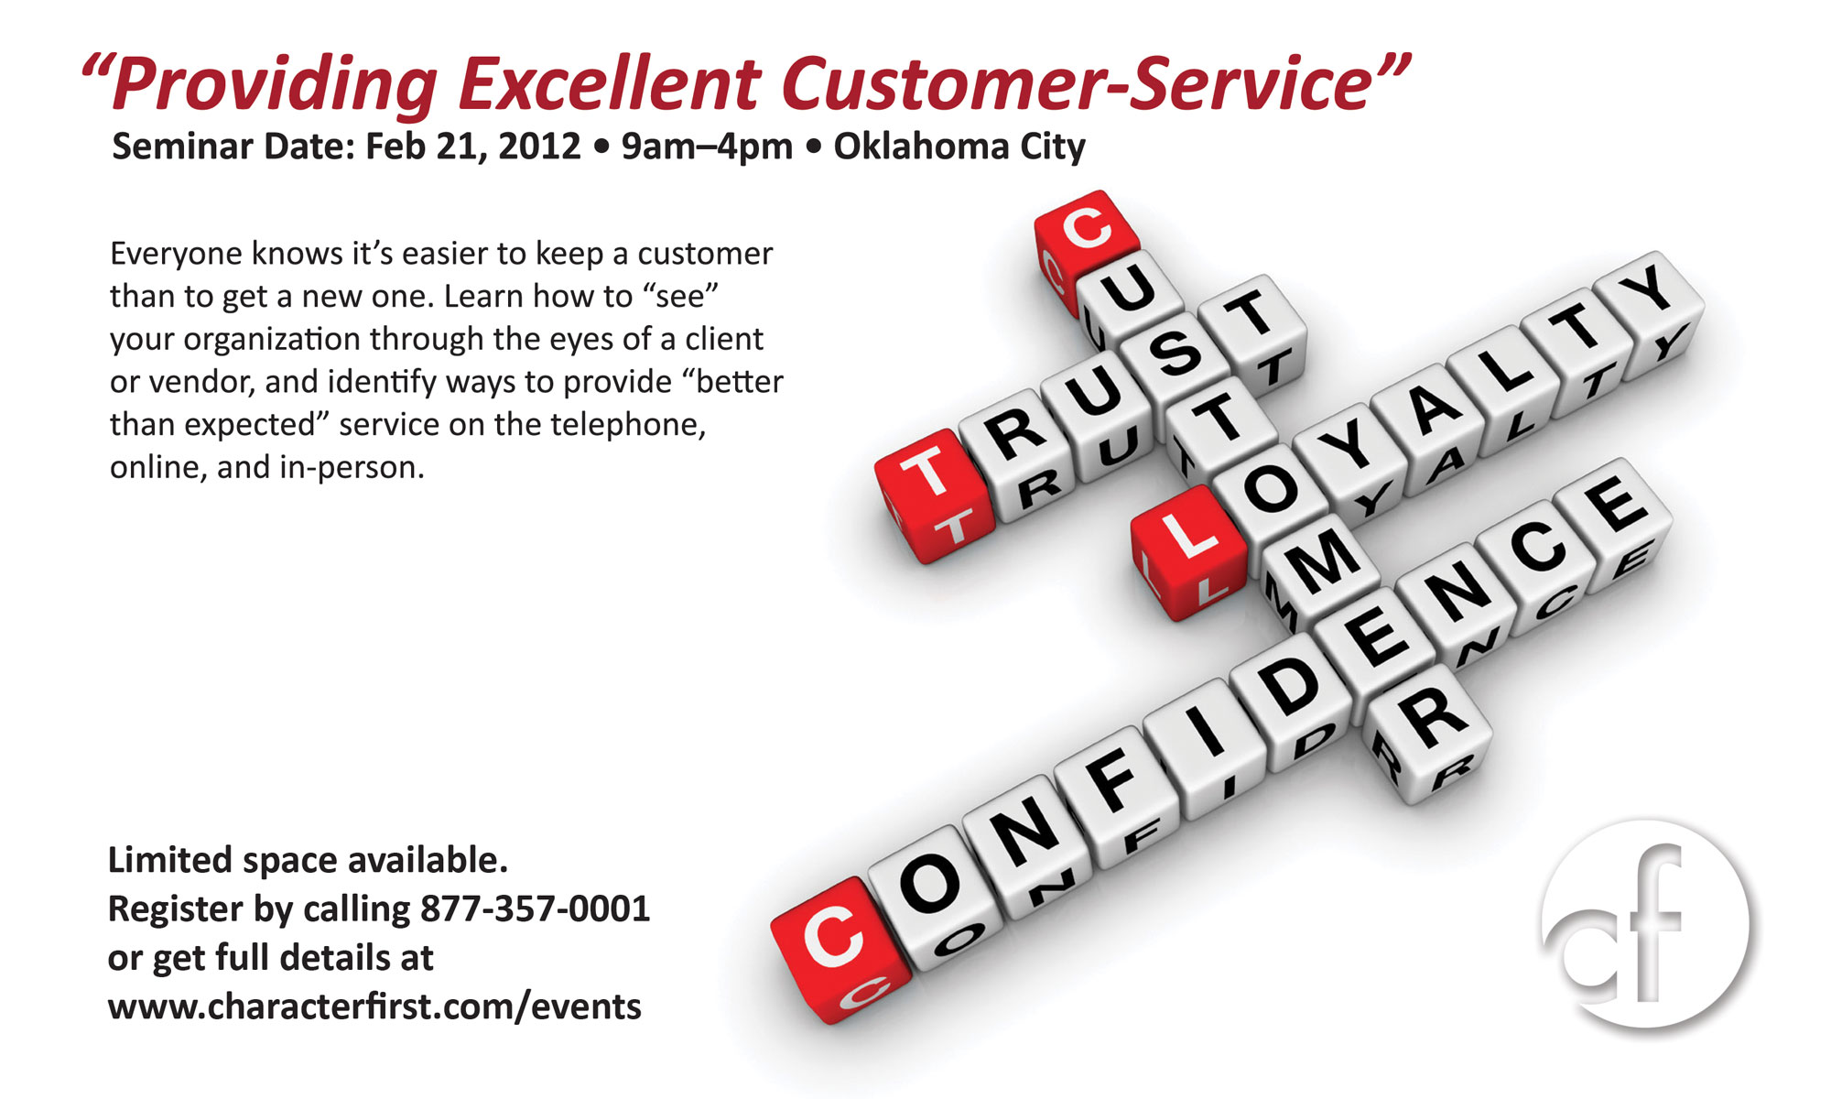

Character Council of Central Oklahoma
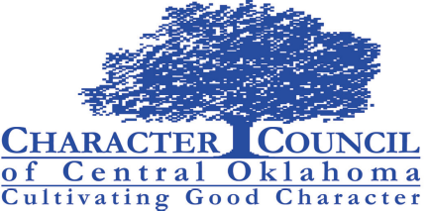
February 28 – Sheriff John Whetsel
“Compassion vs. Indifference”
Cost is $15 per person; Reservations made via luncheon@characterok.org

