Oklahoma Business Ethics Consortium
October 11, 2006 ~ 11:30 to 1:00
Agenda

I. WELCOME & KUDOS Shannon Warren, Founding Director
  - Connie Barwick – Maximum Multi Media Creations for the pre-meeting Power Point presentations
  - Greg Byers & Mary Kay Huggard with Principal Technologies Inc. for spearheading our
registration process
  - UCO Student Chapter President Pat Schafer, Langston’s Rhonda Hudson and Rose State College Representative Tanner Hayes for help with registration
2006-07 Board Recognition Awards:
Starting a non-profit is no easy task. OkEthics has grown from 6 members to nearly 450 statewide. We could not have done this without the tireless work and passion of our dedicated volunteers – particularly those serving in a leadership capacity.

Consortium Board:
- Shannon Hiebert, Enterprise Rent-A-Car – Founding Member; Former VP of Membership;
Currently serving as President, OKC Chapter & State Council
- Diana Wall, Accel Financial Staffing – Treasurer (2003 – 2006), OKC Chapter & State Council
Special thanks to Renee Kissler and Shannon Anderson – Registration Team
- Valerie Fried, Capitol Abstract & Title – Founding Member;
VP of Public Relations, State Council
- Les Brown, Moore-Norman Technology Center – (2006) First President of
Moore-Norman Chapter
- Myrna Latham, McAfee Taft Law Firm – General Counsel, State Council

Foundation Board:
- Bob Byrne, Boeing – President
- Janice Dobbs, Devon – Vice President
- Craig Pitts, Rubenstein Bryan McCormick Pitts PLLC – General Counsel

  - Acknowledgement of NEW Board Members (2006-07)
    - David Mayfield, Eide Bailly LLC – Treasurer
    - Buck Irwin, Nextep – Moore-Norman Chapter President

II. MEMBERSHIP DRIVE – JOIN/RENEW NOW!!!!!!!! Shannon Hiebert, President
- Acknowledgment of STAR members:
Chesapeake, Devon, Enterprise Rent-A-Car, Express Personnel, Nextep, Principal Technologies,
SandRidge Energy
- Acknowledgement of HORIZON members:
Valir Health & Eide Bailly
- See our website at www.okethics.org for a more complete listing of companies
- Drawing for door prize – Lies! Lies! Lies! Book to be signed by Dr. Ford

Oklahoma Stars = $5000 (Prepaid Events for 8, including Awards Banquet)
Individual Membership Levels: Corporate or Group Membership Levels:
⁮ Scout (formerly “Individual”) = $50 ⁮ Frontier (formerly “Corporate”) = $300
⁮ Trail Blazer (formerly “Fellowship”) = $500 ⁮ Leading (Same) = $1200
⁮ Navigator (formerly “Sustaining”) = $750 ⁮ NEW Horizon (Prepaid group rates) = $2500

- UPCOMING CONSORTIUM EVENTS – Advance reservations required for all events
www.okethics.org or call 858-2233
NOTE: Members of the Oklahoma Business Ethics Consortium frequently share information concerning various issues and developments that may have legal implications. The discussions, commentary, and handouts at Consortium meetings or presentations to other organizations are for general informational purposes only. They cover only some aspects of the subject topic, and do not constitute a complete legal analysis of the topic or how it might apply to any particular set of facts. Before taking any action based on information presented by a Consortium member, participants are encouraged to consult a qualified attorney. The observations and comments of presenters at Consortium meetings and networking are the views and opinions of the presenter and do not constitute the opinion or policies of the Consortium or any of its members.
__________________________________________
YOU MAY REGISTER FOR ANY UPCOMING PROGRAMS THROUGH OUR WEBSITE AT www.okethics.org OR CALL 858-2233.

OKC Chapter
November 8 – “Character & Integrity”
Presented by OCU’s Business Dean,
Dr. Vince Orza
**CPE Credit””

December 13 –
“Strong Character Guides Professional Conduct”
***CLE CREDIT***

A study of the Character behind the Oklahoma Rules of Professional Conduct
Co-Sponsored by the Character Council of Central Oklahoma
Presented by Jack Gilchrist, Debee Gilchrist Law Firm

Tulsa Chapter

October 26 – Jeff Mulder, Director, Tulsa Airport Authority

November 16 – Steve Turnbo, Chair, Tulsa Metro Chamber of Commerce
December 13 – Joint meeting with Tulsa Chapter of CPA’s, Internal Auditors and IMA

January 25 – Rick Wagner, Partner-in-charge, Eide Bailly

IV. Other Programs Related to Ethics
Character First – Business Leaders Breakfast/Luncheon
“Hospitality”
Tuesday, October 24: 7:00 a.m. – 8:00 a.m.
Thursday, October 26: Noon – 1:00 p.m.
RSVP: 815-0001 or visit the Character Council Website at http://www.characterok.org/

V. Keynote: Dr. Charles Ford, Author of Lies! Lies! Lies! 12:10

VI. ADJOURN 1:00

PLEASE HELP US CONTROL COSTS – LEAVE YOUR NAME TAG WITH US!

CPE CREDITS – PICK UP AT THE REGISTRATION TABLE;
INSERT NAME ON CERTIFICATE BEFORE LEAVING


OKETHICS CONTINUES TO GROW AND FLOURISH THANKS TO THE STRONG SUPPORT OF OUR MEMBERS!
STAR MEMBERS
($5,000 Contributors)
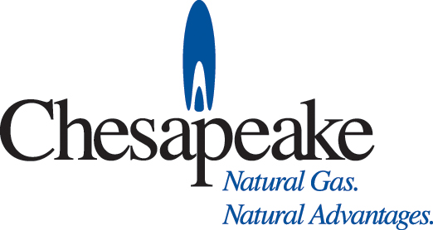

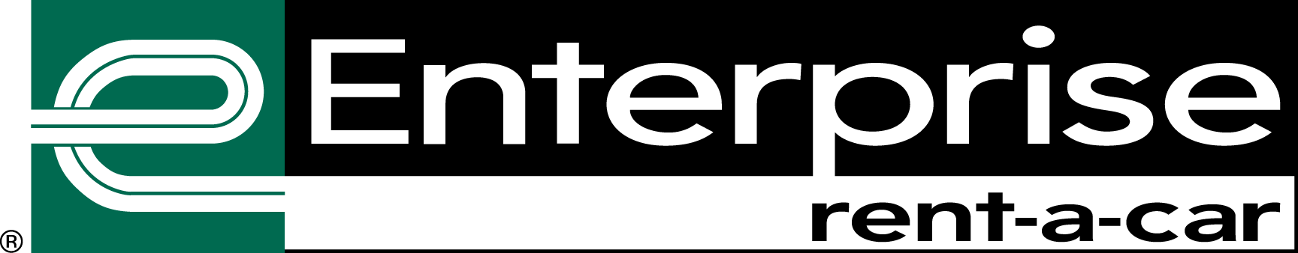





HORIZON MEMBERS
($2,500 Contributors)
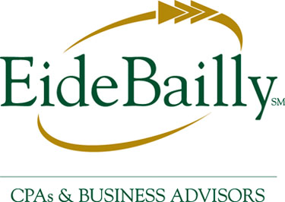
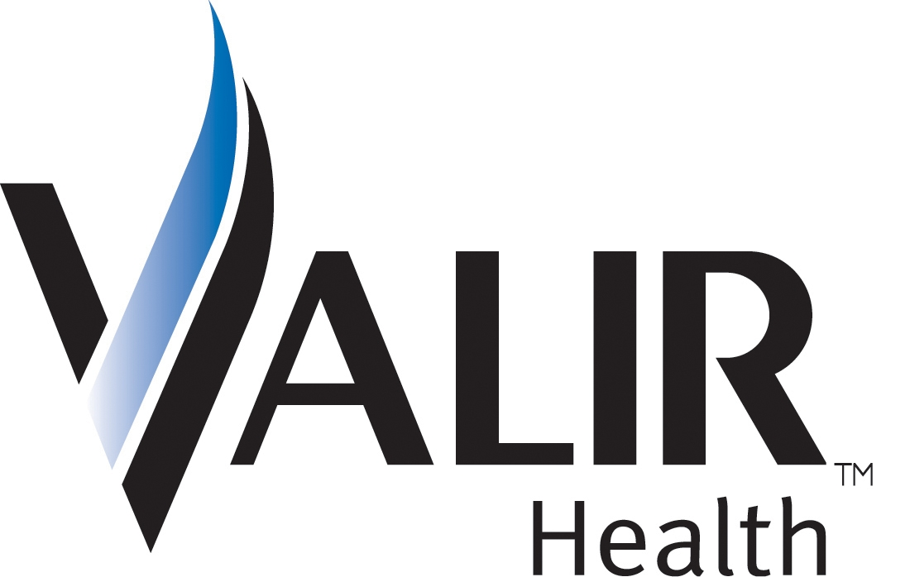


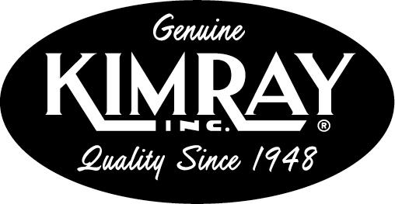
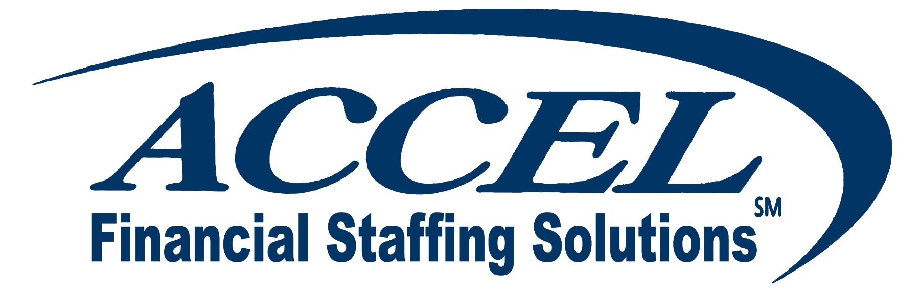
leading members (okc)
($1,200 Contributors)

navigators ($750) & TRAILBLAZERS ($500)

CICERO INTERNATIONAL ADVERTISING
DIGITAL WEST
ROGER HICKS & ASSOCIATES
OKC BUSINESS
JACQUE BERGMAN
BERRYHILL INSURANCE AGENCY
THE FOUNTAINS AT CANTERBURY
MYRNA LATHAM, MCAFEE TAFT
RICHARD MOORE
SHANNON WARREN

OKLAHOMA BUSINESS ETHICS
OFFICERS
FISCAL YEAR 2006 - 07
All positions are voluntary, non-compensated seats. Officers for FY ’07-08 received membership approval in a vote tallied last week. Currently, the VP of Membership position remains open with no nominees suggested at this time. It is expected that the gap will be temporarily filled by former VP, Shannon Hiebert.
President - Shannon Hiebert
Enterprise Rent-A-Car (Oklahoma City)
A Founding Member of OkEthics beginning in 2003, Shannon has served as Vice President of Membership for the Consortium since her appointment to the Board in 2004. She is Group Human Resources Manager for
Enterprise Rent-A-Car in Oklahoma City. Beginning in September, 2006, Shannon will be expected to fill a two-year term, one as President and the other as At-Large.
FOUNDING DIRECTOR - SHANNON WARREN
WARREN CONSULTING LLC (Oklahoma City)
Since the group's inception in October, 2003, Shannon has served as the Director on a non-compensated voluntary basis. To ensure continuity, she serves in this capacity on both the Consortium and Foundation Boards. This position serves at the pleasure of the Board and no term limits have been established.
PRESIDENT (Foundation) & VP OF EDUCATION & MENTORING (Consortium) - BOB BYRNE
BOEING (Oklahoma City)
Bob wears two hats - one as President of the Foundation, the 501c3 organization that supports university efforts and student chapters. He simultaneously acts as a VP on the Consortium Board to ensure continuity of communication between the two groups. Bob was appointed to the Board in January, 2005, subsequent to Harry Whitney's resignation to relocate out of state. Bob is the Ethics Advisor for Boeing Bob was appointed to a two-year term, with the option for continuance after January 2007 at his and the Board's mutual consent. This vote will extend his position through January, 2008.
PRESIDENT (Tulsa Chapter) - GENE BISHOP
Northpoint Wealth Management, LLC (Tulsa)
An experienced financial advisor, Gene was appointed to the Board in the capacity of VP, Development in December, 2005. The VP of Development position was dissolved in July, 2006, - at which time, the Board elected Gene to the position of President-Elect for the Tulsa Chapter. As such, he will be expected to serve two years - one as President and one as an At-Large member of the Tulsa Board.
PRESIDENT (Moore-Norman Chapter) - BUCK IRWIN
Nextep (Norman)
In July, 2006, Buck became one of the newest nominees to the Board. He is Chief Operating Officer for Nextep, a Norman-based consulting firm that was recently awarded the honor of "Best Places to Work" As President of the Norman chapter, he serves as a voting member of the Consortium and will be responsible for Chapter growth. Term will expire in July, 2007, unless renewed by a nomination or Board vote.
GENERAL COUNSEL(Consortium) - MYRNA SCHACK LATHAM
McAfee & Taft Law Firm (Oklahoma City)
A "go to" person in the arena of legal ethics, Myrna was appointed to the Consortium Board in April, 2005, She has played a crucial role in establishing both the Consortium and Foundation as non-profit organizations. A term limit has not
been established for this position.
GENERAL COUNSEL (Foundation) -H. CRAIG PITTS
Rubenstein, Bryan, McCormick & Pitts PLLC (Oklahoma City)
Craig is a CPA & experienced attorney who was appointed to serve the
Foundation Board in February, 2006. Craig has been invited to serve a one-year term, with the option for continuance after February 2007 at his and the Board's mutual consent

SECRETARY (Consortium) - ROB MARTINEK
The Bama Companies (Tulsa)
Rob is Director of Legal Services and Finance for The Bama Companies, the only Oklahoma company to receive a national Malcolm Baldridge Award. He was appointed to the position in September, 2005. Rob was invited to remain in his current capacity on the Board through the new fiscal year of 2006-07.
TREASURER (Consortium & Foundation) - DAVID MAYFIELD
Eide Bailly LLP (Oklahoma City)
David, a CPA, a native of Oklahoma City, has served as a senior manager at Eide Bailly, LLP, since 2000. He heads the audit department in Oklahoma City and is expected to help OkEthics implement procedures in accordance with the non-profit Standards of Excellence. David will be the newest appointee, effectively assuming his duties for a
one year term in September, 2006.
VICE PRESIDENT, PUBLIC RELATIONS - VALERIE FRIED
CAPITOL ABSTRACT (Oklahoma City)
Valerie is Executive Vice President - Finance/Human Resources Director for Capitol Abstract & Title Company. She is a Founding Member of OkEthics and has served as Chair of the Public Relations Committee for the past two years, before being appointed to the Consortium Board as Vice President in March, 2006. A term limit has not been established for this position.
AT-LARGE MEMBER (Foundation) - JANICE DOBBS
Devon Energy (Oklahoma City)
Janice has served as a voting member on the Foundation Board since May, 2005. She was instrumental in helping us launch the Oklahoma Executives for Business Ethics initiative. A term limit has not been established for this position.
AT-LARGE MEMBER (Consortium) - LYNN FLINN
EWF International (Tulsa)
Lynn has served in the capacity of President since the Tulsa inception of OkEthics in April, 2004. She was instrumental in establishing the Tulsa chapter and will be providing continuity as a voting member of the Board for the next year,
through September 30, 2007.

